**Icons:** ActiveDesktop gives you the ability to customize your desktop with icons that serve as shortcuts to applications, allowing you quick access to your most frequently-used programs. You can also create custom icons for the desktop that can act as shortcuts to outside websites.

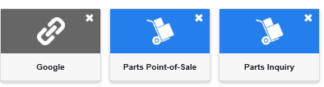

**Creating an Application Icon:** To create a new icon:

* Find the desired application on the menu.
* Click on the application name and hold down the left mouse button while dragging the cursor over the desktop to the location where you want the icon to appear.
* Release the mouse button to put the icon on the desktop.

**Creating a Custom Link:** The last item on the ActiveDesktop Menu is titled “Custom Link.”

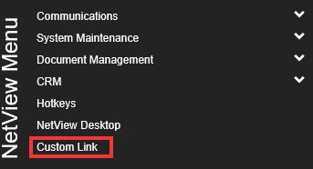

To create a link to a webpage outside of ActiveDesktop, click this option name and hold down the left mouse button while dragging the cursor over the desktop to the desired location, as you would when creating a regular icon. Once you release the mouse button, the following window will appear:

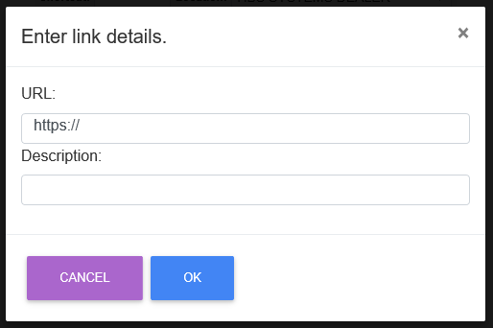

Enter the webpage’s URL and the description you want to appear as the icon’s label on the desktop. Click **Ok** to create the link, and it will appear as a new icon on the desktop (see the “Google” icon at the top of the page for an example).

**Removing an Icon:** To remove an icon from the desktop, click the “x” in the upper right-hand corner of the icon. The following window will appear:

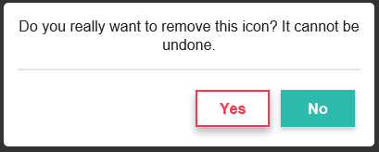

* Click **Yes** to remove the icon from the desktop.
* Click **No** to leave the icon.

**NOTE:** Despite the message, you can always manually re-add the icon to your desktop. This process merely removes that single icon; it does not prevent you from ever placing that icon on your desktop again.